

Years ago, there was a show for children, thinking most of us remember “Barney the happy purple Dinosaur”? There was a song he used to sing to the children… Clean up clean up, everybody everywhere ... Clean up clean up, everybody do your share! I still sing this song when encouraging my grandchildren to clean up their messes.

Such a simple message! Yes, it is meant to teach everyone to do their part. Take responsibility to cleanse! Springtime cleaning is here. I always feel so much better when I remove the clutter and unnecessary items from my space. This physical act of purging can also relate to our mind, our body, our spirits. Letting go of the clutter we hold in our minds, past grievances, or stories we replayed... Move on, forgive and purge! Letting go of “the stuff that clutters our being.” Cleansing our physical space helps as it creates the path for the mind to purge also. I have noticed within myself how much better I feel, not to mention how much nicer my home feels when this physical purging takes place! Rid myself of the dust bunnies that also cloud my mind.

So, I challenge you to clean up clean up, everybody everywhere... Clean up, clean up everybody do your share!! Walnut Cove you’re really stepping up and doing your part! The POA is doing very few forced cleanups! The dumpster day and limb day are really being utilized! It's so awesome!!! Donate your excess to local charities, donation drop boxes, local churches, or Goodwill. The entire decor we have used for the pavilion has come from people's unwanted things. All now refurbished and utilized for a better cause. Remember your trash maybe someone else’s treasure!

So, let's keep the attitude of cleansing our physical space, and remove thoughts of negativity from our being! Rid yourself and your spirit of the unwanted dust bunnies! Freshen up every part of yourself! Take that message from the happy purple Dinosaur! He always had a smile on his face. God bless and enjoy this beautiful spring in the Cove, thank you! -Terri Saxton

Lessons from the

“Purple Dinosaur”

## Board Meetings

**The 3rd Monday of the Month @ the pavilion, 6:30pm.**

**April 20, 2020** (possibility of cancelling; will inform via Facebook and by mailboxes)

**May 30, 2020 ANNUAL MEETING – Sat, 1pm**

**June 15, 2020**

## Board of Directors

President: Jeramy Chaffin

Vice President: Mark Wofford

Treasurer: Laronda Zurovec

Secretary/Beautification: Terri Saxton

ACC Chair: Tommy Seilhan

Deed Restriction Chair: Rhonda Russell

CONTACT US:

walnutcovepoa@yahoo.com

Find our group on Facebook:

"Walnut Cove Information"



Walnut Cove POA

11182 Apple Tree | Willis, TX 77318 | 936-701-4036 | www.walnutcovepoa.com

**Cleaning hacks**

**to save $$$**



**All-time top 3 cleaning hacks with baking soda are**:

* Bin deodorizer**:** Next time you empty your bin, sprinkle some baking soda at the bottom — it will absorb those nasty odors!
* Cleaning the cooker-hood filters: The only way to get rid of that sticky layer of grease is to soak it with boiling water and baking soda.
* Cleaning grout**:** Not only is baking soda an abrasive, it’s also a natural whitener — perfect for the grout in bathroom!

**Steam Clean Your Microwave**:

* Cut a lemon into two halves and place them in a (microwaveable) bowl/jug of water.
* Place the bowl in the microwave and heat for 3 minutes. Leave the bowl to stand for around 5 minutes.
* Heating water in your microwave generates steam, which, along with the lemon (a natural de-greaser), helps to loosen the dried-on food and stains inside your microwave.
* When you remove the bowl, your microwave shouldn’t need anything more than a quick wipe to clean!

**DIY Overnight Mold Remover**:

* Soak cotton wool balls in bleach (be sure to use rubber gloves!) and lay them on those annoying mold and mildew stains that form on the grout/sealant in your bathroom.
* Leave them to work overnight (while you catch up on some well-deserved sleep) and simply remove them the next day — the mold will be gone!

**DIY Disinfecting Spray Cleaner:**

* 1 1/4 cups water.
* 1/4 cup white vinegar.
* 1/4 cup vodka (excellent germ-killing properties – you can substitute rubbing alcohol, but it will have a more medicinal scent)
* 15 drops essential oil – peppermint + lemon OR lavender + lemon is great in this recipe.
* Glass spray bottle.



* **Dumpster Days**

Every second Saturday of the month at back mailboxes from 8am to 12pm or full.

* **Limb Days**

Last Saturday of every month will be at the boat ramp from 8am to 12pm. (Watch the Facebook information page for possible additional days)

Please call office if you need to schedule a time to come dump limbs. 936-701-4036



**Upcoming NW Meetings:**

**April 18-11:00am**

**May 16-11:00am**

**June 20-11:00am**

**Meetings will be held at the Pavilion**



   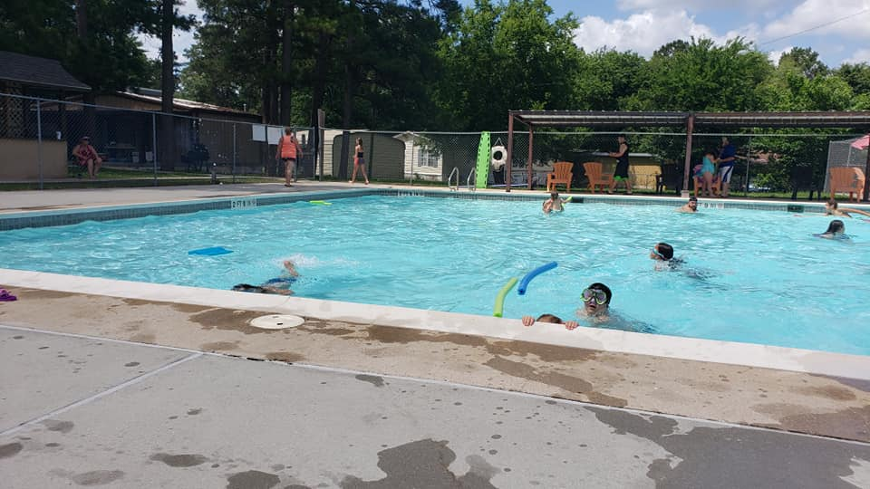  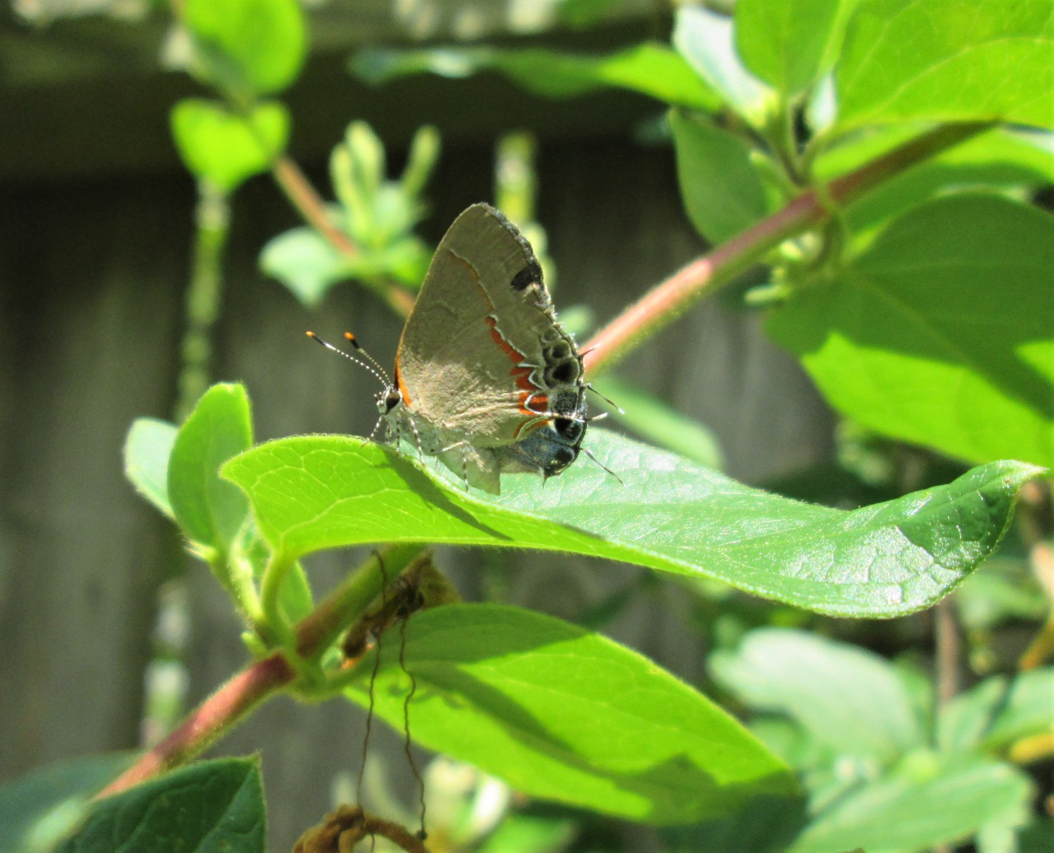



First meeting with Commissioner, The Road superintendent has done analysis on our roads. Paving season will begin in April 2020. All conditions depend on weather, budget, and immediate needs. Waiting to hear back, so cross your fingers. It will begin soon!!! Thanks to everyone in the Community who voted and made this possible for our roads.

POOL INFORMATION

All pool repairs will be completed before pool opens Memorial Day weekend. The new pool tags will be available that opening weekend as well. All maintenance dues will need to be paid in order to get tags. If you have renters living on property, make sure to give all renters names and addresses to the office for them to pick up tags with pool/office. If there are any questions call the office. 936-701-4036 or email [walnutcovepoa@yahoo.com](mailto:walnutcovepoa@yahoo.com).





**DO THE FIVE**

**Help stop COVID-19**

**1HANDS** Wash them often

**2ELBOW** Cough into it

**3FACE** Don't touch it

**4FEET** Stay more than 6ft apart

**5FEEL** sick? Stay home



BOAT DOCK

We are taking bids currently to

repair the boat dock.

**\*Please do not use it as it is unsafe as this time!\***

**ACC Applications**

Planning improvements? Please submit an ACC application to Lindsey McKibbins at the Walnut Cove office.

* Building a fence
* Adding a shed
* Adding a room to your home
* Bringing in or building a new home
* Moving in an RV, travel trailer or any other type of building/home/structure

Please call 936-701-4036 for more information.





## PAVILION IS READY FOR RENTAL

**PAVILION/BUIDING RENTAL**

Pavilion-outside patio only - no chairs, no bathroom access, Walnut Cove

Residents only, no outsiders **($50.00 deposit refundable once cleaned up)** $ 100.00/deposit

**(4-hour min.)**

Pavilion-inside- rental includes table, chairs and usage of kitchen $ 75.00/hr. – 2-hr min

**($200.00 Deposit/refundable if no damage**)

**Ladies Group**

To be announced!! Please pay attention to Facebook or check in with the office for more information!

If you would like more info, contact Terri Saxton at [saxton.terri@gmail.com](mailto:saxton.terri@gmail.com).

